|  |  |  |  |  |
| --- | --- | --- | --- | --- |
| |  |  | | --- | --- | | **Commonwealth of Virginia**  **Office of the Attorney General**  **Jason S. Miyares**  **Attorney General**  202 North Ninth Street  Richmond, Virginia 23219  (804) 786-2071  Fax (804) 786-1991 | **Commonwealth of Kentucky**  **Office of the Attorney General**  **Daniel Cameron**  **Attorney General**  Capitol Bldg., Suite 118  700 Capital Avenue  Frankfort, KY 40601  (502) 696-5300  Fax: (502) 564-2894 | | | |
|  | July 21, 2022 |  |

Mr. Sundar Pichai

Chief Executive Officer

Alphabet Inc.

1600 Amphitheatre Parkway

Mountain View, California 94043

**Via Email and U.S. Mail**

Re: Google Must Not Discriminate Against Crisis Pregnancy Centers.

Dear Mr. Pichai:

Google accounts for more than ninety percent of all internet searches in the United States. It also holds a dominant position in the market for online advertising. This dominant market position comes with a tremendous responsibility to Google’s users and to the American public. Google once recognized its outsized public duty in its corporate motto “don’t be evil” and in its commitment to “providing our users unbiased access to information.”[1] Unfortunately, several national politicians now seek to wield Google’s immense market power by pressuring the company to discriminate against pro-life crisis pregnancy centers in Google search results, in online advertising, and in its other products, such as Google Maps. As the chief legal officers of our respective States, we the undersigned Attorneys General are extremely troubled by this gallingly un-American political pressure. We wish to make this very clear to Google and the other market participants that it dwarfs: If you fail to resist this political pressure, we will act swiftly to protect American consumers from this dangerous axis of corporate and government power.

In their June 17, 2022 letter to you, Senator Mark Warner and Representative Elissa Slotkin, joined by 19 other Democrat Senators and Members of Congress, complained that Google users who search for “abortion services” are shown results for crisis pregnancy centers, which the letter derides as “anti-abortion ‘fake clinics.’”[2] The Democrat lawmakers urged you to “take action to prevent anti-abortion fake clinics from appearing in search results,” and demanded a response detailing how you will do so.[3] Not long after Senator Warner and Representative Slotkin’s letter, the New York Attorney General echoed their demands,[4] and Senator Elizabeth Warren recently called for crisis pregnancy centers be “shut down all around the country.”[5]

That Members of the United States Congress would openly call for the full weight and power of the federal government to shut down private charitable organizations that have shown compassion and love to so many vulnerable women over the years is unconscionable. It is the opposite of how a pluralistic society that values diversity of viewpoints must operate if it is to survive.

According to a 2020 study, crisis pregnancy centers served over 1.8 million clients in 2019, providing services valued at $266 million at little or no cost to their patients.[6] These services included free ultrasounds, pregnancy tests, testing for sexually transmitted diseases, parenting and prenatal education classes, post-abortive care and recovery counseling, and free or reduced-cost diapers, baby clothes, car seats, and strollers.[7] These pregnancy centers serve women, no matter who they are or what they believe. Left-wing politicians’ sneering insults toward crisis pregnancy centers and their important work is all the more disturbing because it comes at a time when pro-life pregnancy centers are literally under attack by violent pro-abortion activists.[8] These attacks threaten not only those affiliated with the centers, but also the mothers in desperate need of assistance.

Complying with these demands would constitute a grave assault on the principle of free speech. “Unbiased access to information,” while no longer a component of Google’s corporate creed,[9] is still what Americans expect from your company. “[S]tudies have found web users are more likely to find and trust news through search than social media sites.”[10] At least some Google users who search for information about abortion also expect to find information about alternatives to abortion, as evidenced by the simple fact that your search algorithm—free of the manipulation that left-wing politicians are now demanding—consistently produces such results. Suppressing pro-life and pro-mother voices at the urging of government officials would violate the most fundamental tenet of the American marketplace of ideas.

Even according to Planned Parenthood, crisis pregnancy centers “are faith-based organizations that oppose abortion” and “have religious missions,” including to “express the love of Jesus Christ.”[11] Caving in to the demand of some vocal left-wing politicians to manipulate Google’s search results and other services against these organizations therefore also reeks of religious discrimination. In our pluralistic society, Americans who hold strong religious and nonreligious beliefs frequently disagree, just as adherents of different religions frequently disagree among themselves. As the Supreme Court has recently reaffirmed, “[r]espect for religious expressions is indispensable to life in a free and diverse Republic,” and “to ferret out and suppress religious observances” while “allow[ing] comparable secular speech” is discriminatory.[12] No American should be silenced because of his or her religious beliefs, especially in order to magnify the message of adherents of other beliefs on the same subject. The laws of Virginia and Kentucky, like those of many of the States represented here, forbid the denial of services on the basis of religion.[13]

Free markets are a fundamental tenet of American society. But monopolized markets are not free. And Google’s monopoly power in the markets for search services and online advertising has attracted the attention of federal regulators, the Department of Justice, and many of the States—including many of the States represented here.[14] We cannot imagine a potential antitrust violation more odious to American ideals than the deployment of monopoly power to suppress the expression of a particular idea, done at the behest of government actors. Because of the fundamental American values at stake here, if you comply with this inappropriate demand to bias your search results against crisis pregnancy centers, our offices will (1) conduct thorough investigations to determine whether this suppression violates the antitrust laws of the United States and our states; (2) investigate whether Google’s conduct amounts to an unlawful act of religious discrimination under state law; and (3) consider whether additional legislation—such as nondiscrimination rules under common carriage statutes—is necessary to protect consumers and markets.

We trust that you will treat this letter with the seriousness these issues require, and hope you will decide that Google’s search results must not be subject to left-wing political pressure, which would actively harm women seeking essential assistance. If you do not, we must avail ourselves of all lawful and appropriate means of protecting the rights of our constituents, of upholding viewpoint diversity, free expression, and the freedom of religion for all Americans, and of making sure that our markets are free in fact, not merely in theory.

Please respond to this letter within fourteen days with answers to the following question:

Has Google taken, or will Google take, any steps to treat crisis pregnancy centers any differently with regard to Google search results, Google Ads, or Google Maps than they were treated before the leak of the draft United States Supreme Court opinion in *Dobbs v. Jackson Women’s Health Organization*? If so, what steps have you taken, or will you take?

Sincerely,

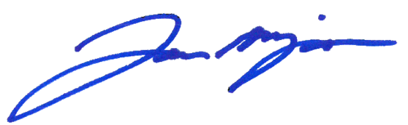

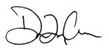

Jason S. Miyares Daniel Cameron

Attorney General of Virginia Attorney General of Kentucky

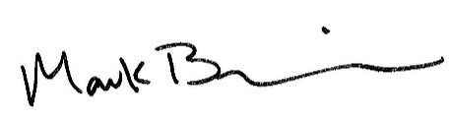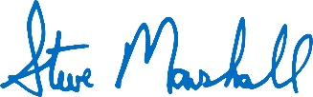

Steve Marshall Mark Brnovich  
Attorney General Attorney General  
State of Alabama State of Arizona

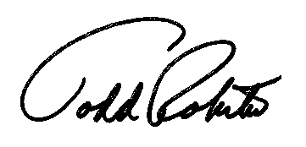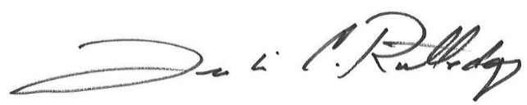

Leslie Rutledge Todd Rokita  
Attorney General Attorney General  
State of Arkansas State of Indiana

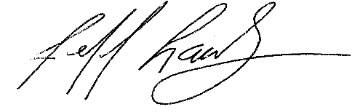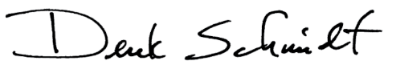

Derek Schmidt Jeff Landry  
Attorney General Attorney General  
State of Kansas State of Louisiana

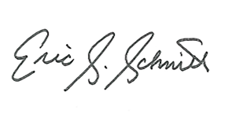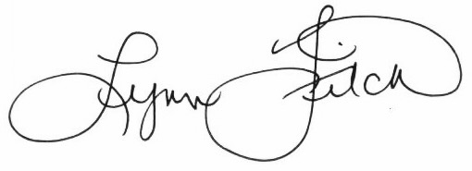

Lynn Fitch Eric Schmitt  
Attorney General Attorney General  
State of Mississippi State of Missouri

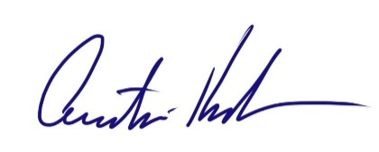

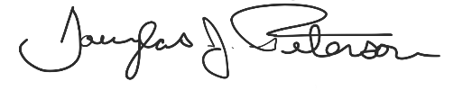

Austin Knudsen Douglas J. Peterson  
Attorney General Attorney General  
State of Montana State of Nebraska

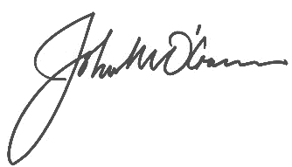

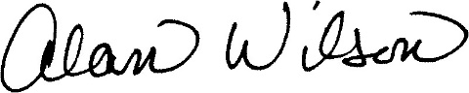

John M. O’Connor Alan Wilson  
Attorney General Attorney General  
State of Oklahoma State of South Carolina

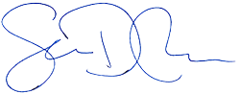

Ken Paxton Sean D. Reyes  
Attorney General Attorney General  
State of Texas State of Utah

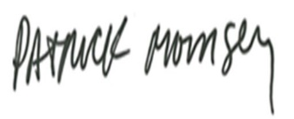

Patrick Morrisey   
Attorney General   
State of West Virginia

CC: The Honorable Mark R. Warner, United States Senator

703 Hart Office Building

Washington, D.C. 20510

1. Internet Archive, *Google Code of Conduct*, captured Apr. 21, 2018, https://bit.ly/3IB7LYh.
2. Letter from Mark Warner, U.S. Senator, et al. to Sundar Pichai, CEO of Alphabet Inc. (June 17, 2022), https://bit.ly/3RMi28f.
3. *Id.*
4. N.Y. Office of the Attorney General, *Attorney General James Calls on Google to Address Dangerous Amplification of Fake Pregnancy Centers* (June 29, 2022),https://on.ny.gov/3yGGxL5.
5. Greg Price (@greg_price), Twitter (July 12, 2022, 4:41PM), bit.ly/3o8SuEk.
6. Charlotte Lozier Institute, *Pregnancy Centers Stand the Test of Time* 24 (2020), https://bit.ly/3azjrhH.
7. *Id.* at 16.
8. Susan B. Anthony Pro-Life America, *Pro-Abortion Vandalism, Violence, and Interruptions of Worship* (June 15, 2022) (detailing more than 40 such attacks across the country between May and mid-June, 2022).
9. Christopher Carbone, *Google Revises Code of Conduct, Removes “Don’t Be Evil*,*”* NY Post May 22, 2018, https://bit.ly/3Pj0uhQ.
10. Danaë Metaxa et al., *Search Media and Elections: A Longitudinal Investigation of Political Search Results in the 2018 U.S. Elections*, Proceedings of the Association for Computing Machinery on Human-Computer Interaction 3, CSCW, Article 129 (November 2019), https://doi.org/10.1145/3359231.
11. Planned Parenthood, Crisis Pregnancy Centers Fact Sheet, https://bit.ly/3uSttkF; see also Charlotte Lozier Institute, *Fact Sheet: What Are Pregnancy Help Organizations?* (May 2021), https://bit.ly/3Pp13Xm.
12. *Kennedy v. Bremerton Sch. Dist.*, 142 S. Ct. 2407 (2022).
13. See Va. Code § 2.2-3904(B); Ky. Rev. Stat. § 344.120.
14. See, *e.g.*, *United States v. Google LLC*, No. 3:21-cv-05227 (D.D.C., filed Oct. 10, 2020); *In re Google Digital Advertising Antitrust Litigation*, No. 1:21-md-03010 (S.D.N.Y., filed Nov. 21, 2021) (suit filed by 17 states); *Utah v. Google LLC*, No. 3:21-cv-05227 (N.D. Cal., filed July 7, 2021) (suit by 36 states, including Virginia).